Invitation

On the occasion of International Women’s Day

The Arabic-Dutch Women Circle (ANVK)

&

Belle Events

Have the honor to invite you for a charity lunch

for the benefit of the Palestinian Women and Children in the demolished Yarmouk Camp in Syria

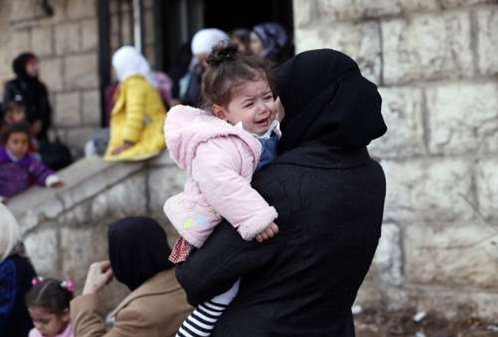
On Saturday 9th March 2013 at 12.30
At Christus Triumfatorkerk
Juliana van Stolberglaan 154
The Hague
Tramline 2 and 6, also bus 23

Program

12.30 Arrival
13-00 Welcome by chairwoman day Basema Spijkerman-Salman
13-10 Welcome by Dr. Tomador Meihuizen- Hassoun, President of ANVK
13.20 Lecture “Women rights and humanitarian law situation in the
Occupied Palestinian territory” by mrs. Laila Jaffar Consultant and
Communication trainer
13.45 Discussion
14.15-15.15 Arabic warm lunch

15.15-16.55 Film “Salt of this sea“ by film maker Annemarie Jacir.
16.55-17.10 Discussion about the film
17.10 Conclusion

Entry fee: € 25 ,- however an extra donation will be very welcome. All the money is meant for the Palestinian women and children in Al-Yarmouk Camp in Syria.
You can pay on the same day or transfer your entry and donation to ANVK account number: ABN AMRO Bank Den Haag 518386783 quoting “Help Yarmouk Camp”.

Friends and partners are also welcome
Please confirm via e-mail before February 25th 2013
t.hassoun@casema.nl or Tomador_hassoun@hotmail.com

Salt of this sea
The first feature film from Palestine by a female director, Salt of this Sea is the politically and emotionally explosive story of Soraya (Suheir Hammad), a Brooklyn-born woman of Palestinian lineage who comes to Israel to search for the land and ancestral home near Jaffa from where her grandparents were ejected 65 years ago. Once she arrives, reality strikes hard and her mission to claim what is hers and fulfill her lifelong dream to "return" to Palestine is obstructed at every turn. Having discovered that her grandfather's bank account was frozen and seized in 1948, she goes to the new Ramallah branch of the bank to claim the funds. Frustrated and deluded when her demands are rebuffed, she and her new Palestinian boyfriend Emad decide to take control of their own destinies by every means possible - even if it means breaking the law.

